Intelligent Employee Scheduler (LTA MRT)

Environment set up for [iss-vm](https://github.com/telescopeuser/iss-vm)

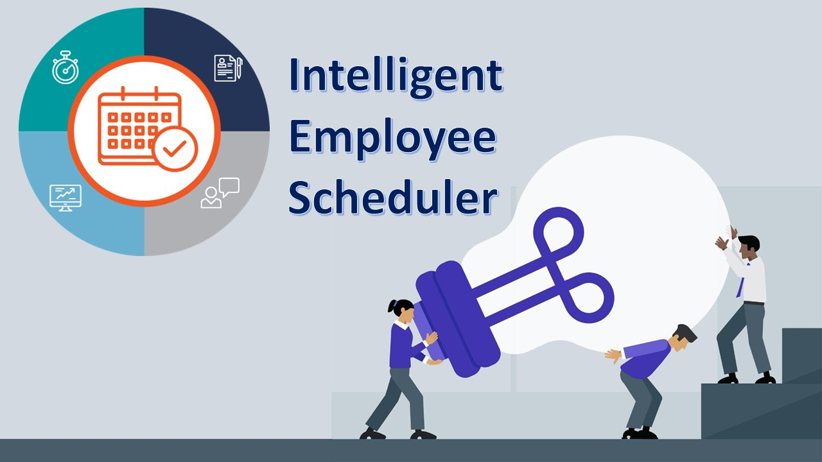

**< Back End Sub-system >**

1. Start backend service, you can navigate to the **/IRS-RS-2019-03-09-IS1PT-GRP-2-GOH-Intelligent_Employee_Scheduler/SystemCode/services** folder and enter

**mvn clean install**

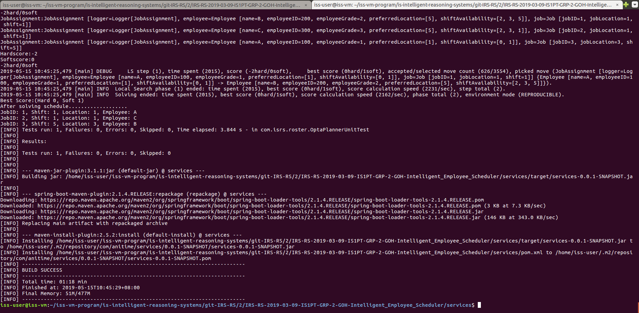

**mvn spring-boot:run**

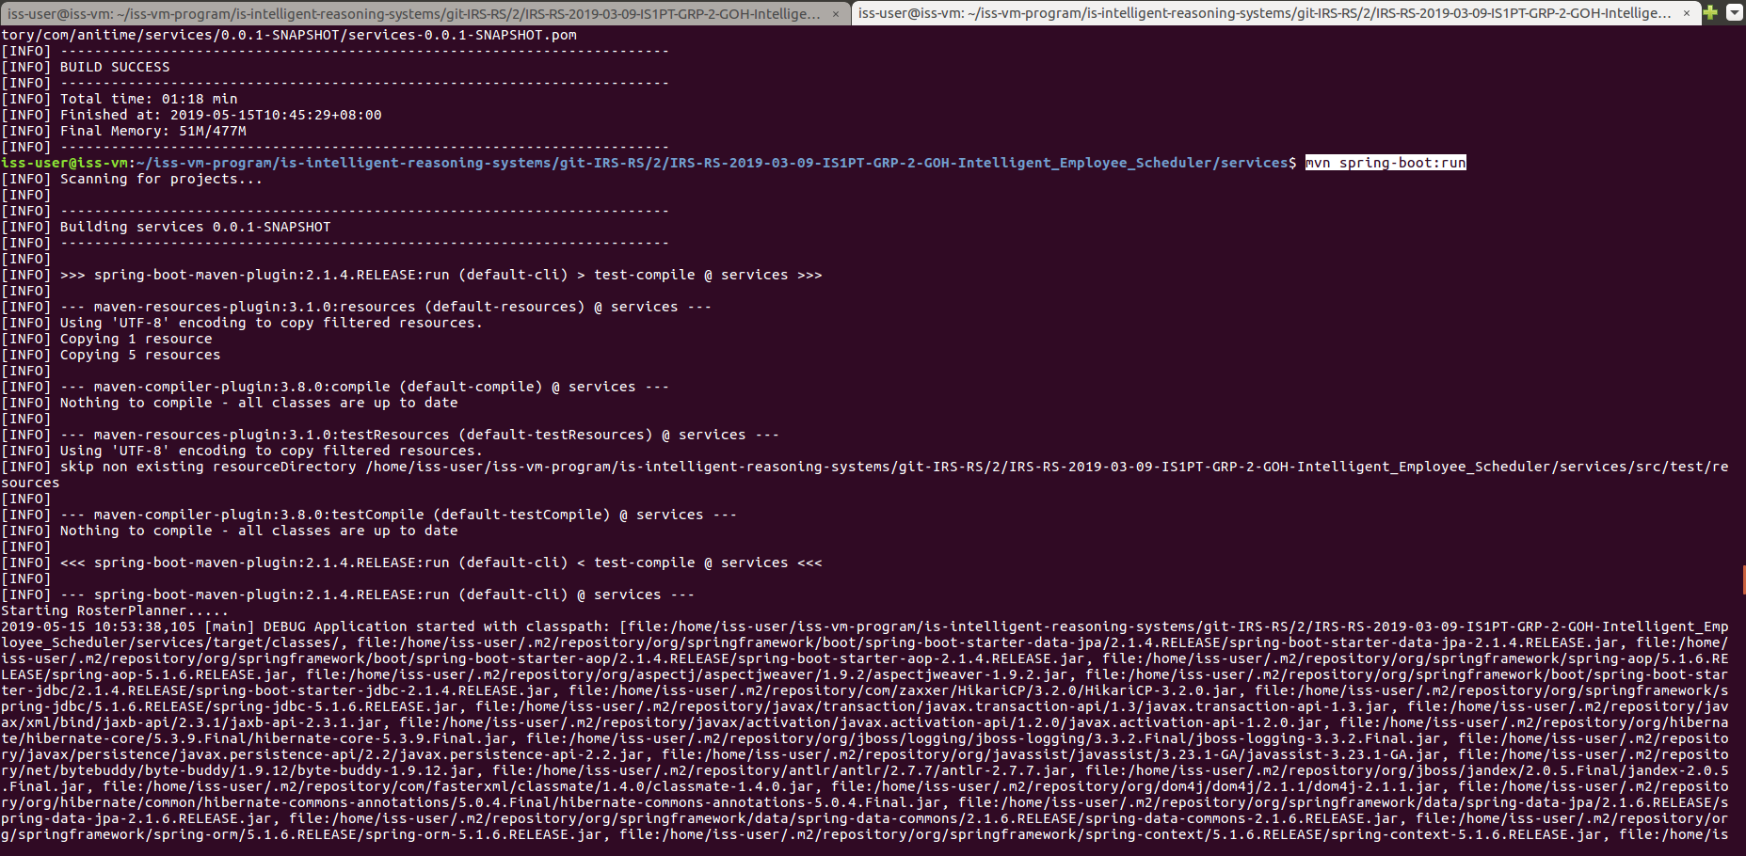

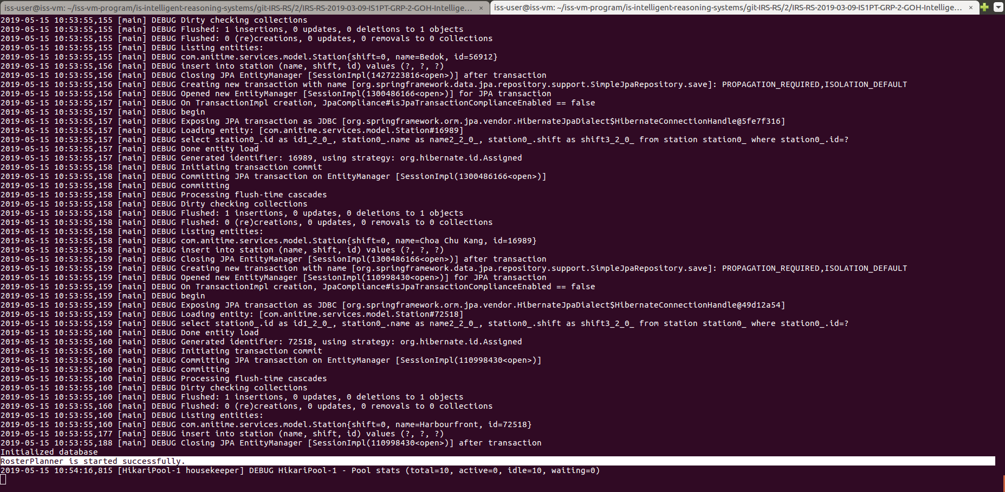

**< Front End Sub-system >**

<https://www.techomoro.com/how-to-install-and-setup-angular-7-on-ubuntu-18-04-1/>

1. Install Nodejs

It can be installed by running the command below on our Terminal.

**curl -sL https://deb.nodesource.com/setup_11.x | sudo -E bash -**

[sudo] password for iss-user: iss-user

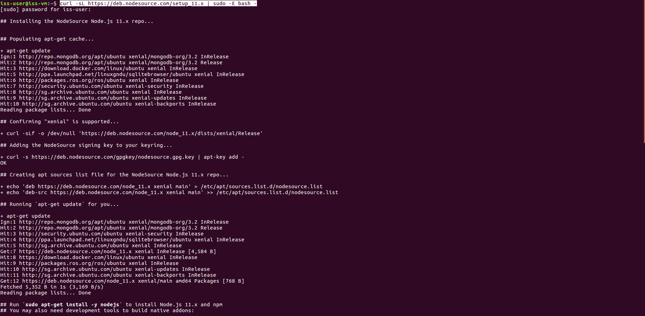

**sudo apt-get install -y nodejs**

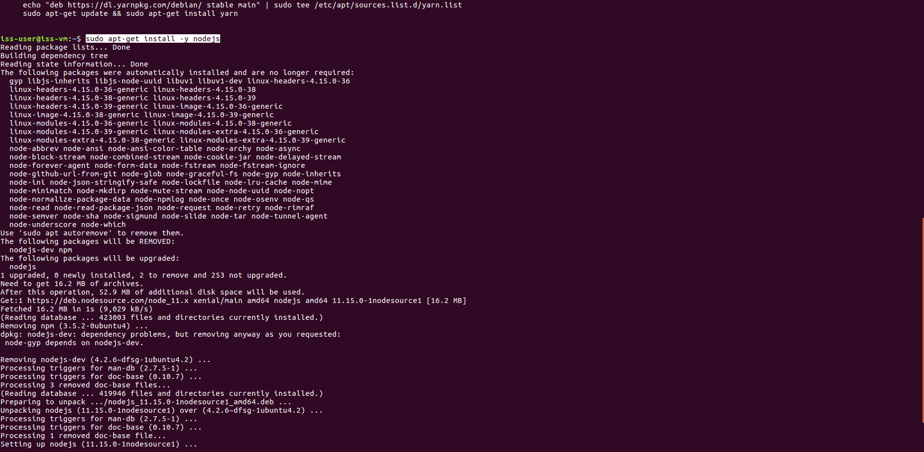

1. Install Angular Cli

It can be installed by:

**sudo npm install -g @angular/cli**

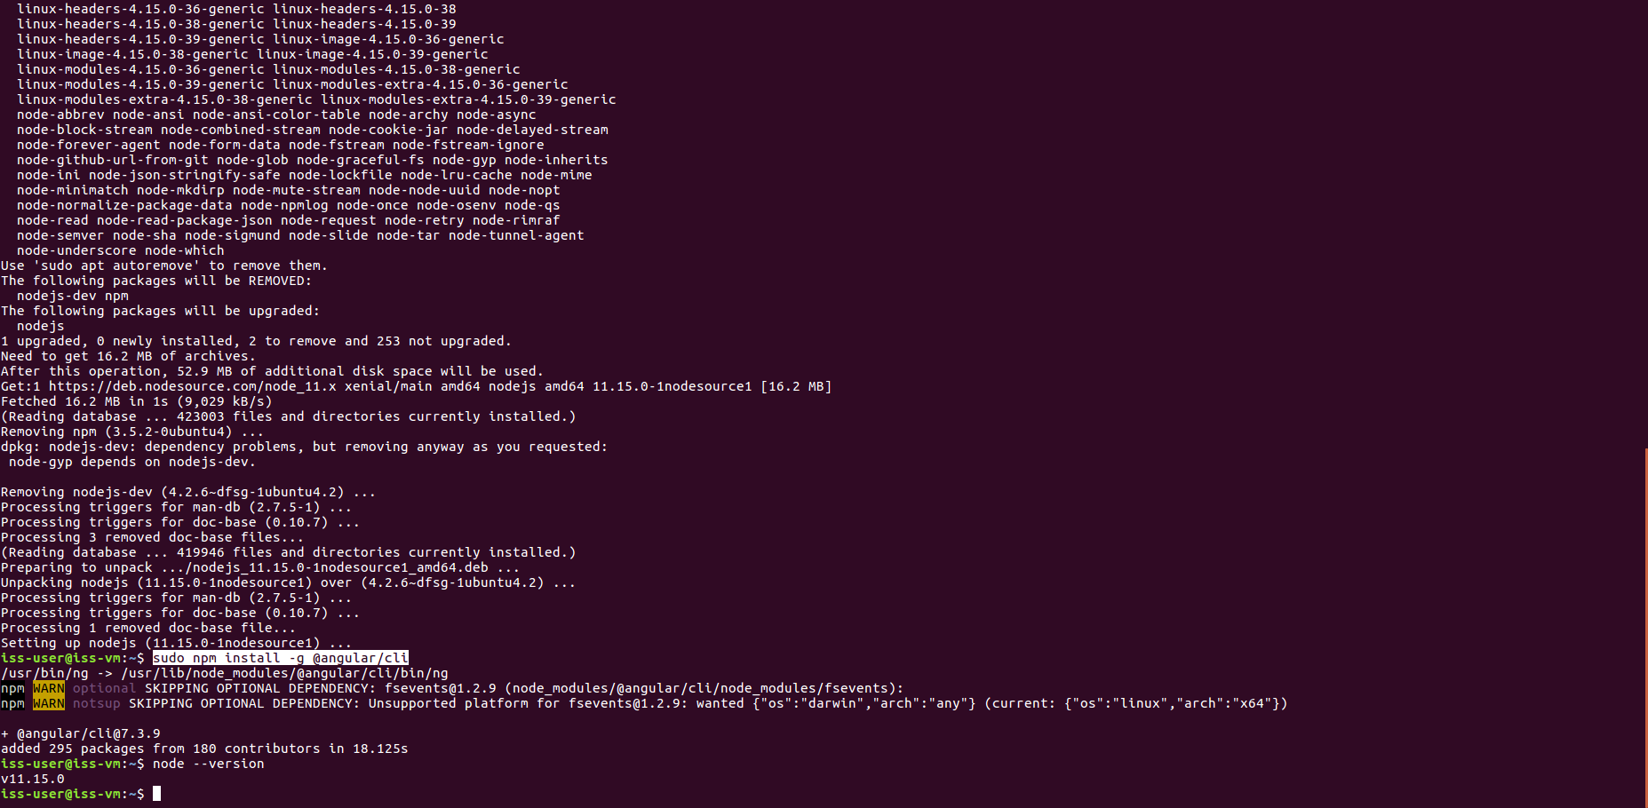

1. Grant user access for npm update check:

**sudo chown -R $USER:$(id -gn $USER) /home/iss-user/.config**

1. Navigate to the **/IRS-RS-2019-03-09-IS1PT-GRP-2-GOH-Intelligent_Employee_Scheduler/SystemCode/frontend** folder and enter

**sudo npm install**

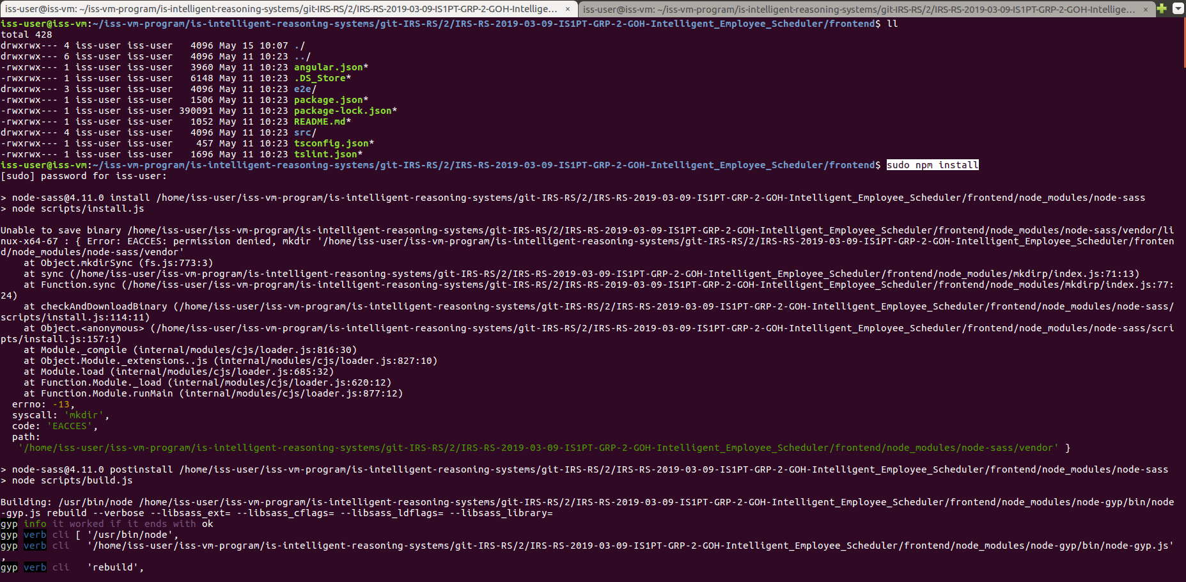

1. Update user access:

**sudo chown -R $USER:$USER \***

1. Run command

**ng serve**

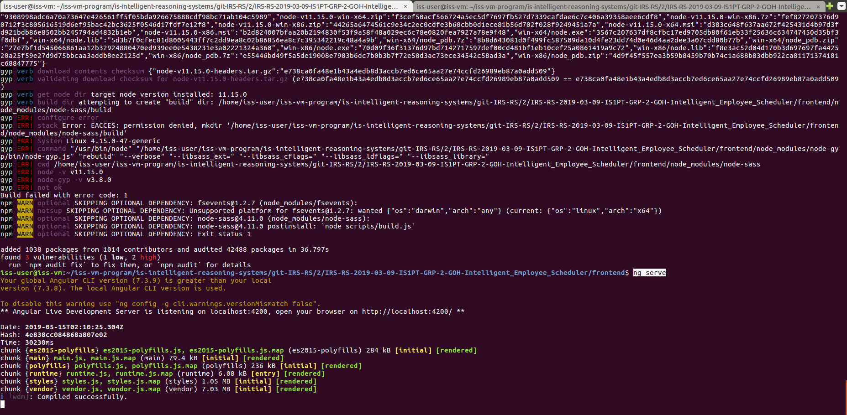

If you get any npm WARN messages you can ignore them as you should still be able to do an **ng serve**. As from the second screenshot, we can still serve the frontend.

1. Open browser, go to: **http://localhost:4200/**

